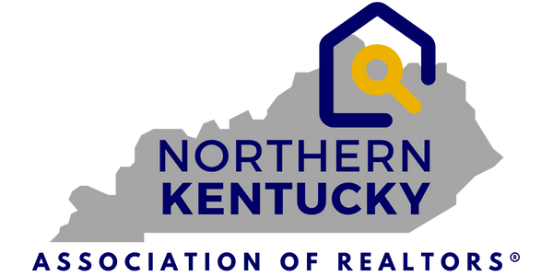
7660 Turfway Rd.
Suite 100
Florence, KY 41042
859-344-8400
FOR IMMEDIATE RELEASE
JULY 23, 2025
PRESS RELEASE
Contact: Jen Swendiman, President
Northern Kentucky Association of REALTORS®
Telephone: 859-344-8400
E-mail: Jswendiman@handinhandrealtyky.com
Northern Kentucky Real Estate Market Update – July 23, 2025
Florence, KY – July 23, 2025 – The Northern Kentucky Association of REALTORS® and The
Northern Kentucky Multiple Listings Service, Inc. (MLS) reported today that in June, year-to-date, new listings in the 12 counties served by the local MLS are up 4.6%.
Shown in the graphic below, Year-To-Date, June home sales were up 6.7% in dollar volume and up in the number of sales by 1.2%, However, the Median Sales price rose by 9.1% to $300,000.
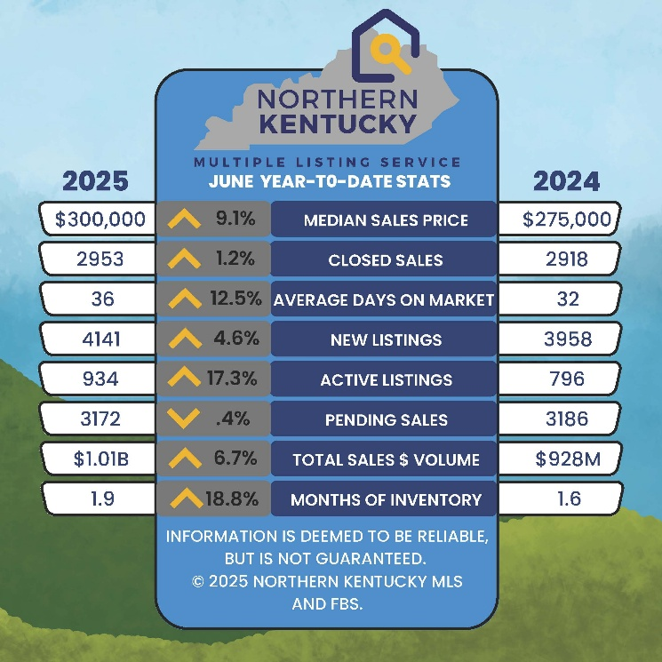

Market Trends (June 2025 v. 2024)
- Closed Sales were 13.3% higher than in June 2024- 589/520.
- Median Sales Price up by 5.3% to $300,000.
- Average Days on Market dropped to 27 days or a 6.9% decrease.
- New Listings trended upward in June to 796 over the previous June, an 16.5% decrease.
- Pending Sales were up from 2024 with 563 v. 524 or an 7.4% increase.
- Sales Volume was higher by 17% or $201.9 million in the June 24/25 comparison.
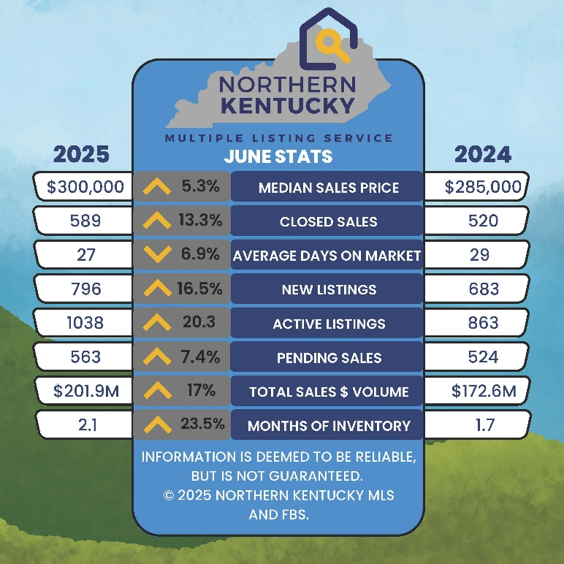
Commenting on these market trends, Jen Swendiman, President of the Northern Kentucky Association of REALTORS®, stated, with New Listings up 16.5% in June 2025 vs. 2024, we are seeing an increase in Total Active Listings by 20.3% over June of 2024. As we are in the active summer market, pending sales continue to increase and Average Days On Market decreased while still improving our total Active Inventory to 2.1 months, up from 1.7 months in June 2024. The National Association of REALTORS® indicated that while mortgage rates continue to hover in the high 6% range, some indicators show more buyers emerging, drawn by the higher inventory of For Sale signs in their markets and potential for more bargaining power.
With almost 1930 MLS users, the Northern Kentucky MLS (NKMLS) is a leader in the real estate information and services business and operates with a professional staff from 7660 Turfway Road, Suite 100 in Florence, KY. Both NKAR and the NKMLS work to protect the public’s right to transfer real property and promote better public understanding of the profession and the real estate transaction process.

