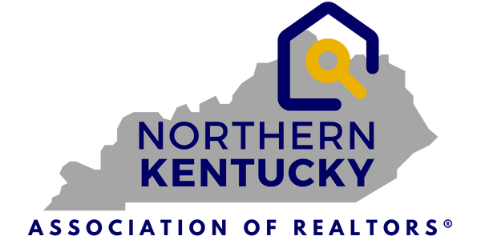
7660 Turfway Rd.
Suite 100
Florence, KY 41042
859-344-8400
FOR IMMEDIATE RELEASE
AUGUST 21, 2025
PRESS RELEASE
Contact: Jen Swendiman, President
Northern Kentucky Association of REALTORS®
Telephone: 859-344-8400
E-mail: Jswendiman@handinhandrealtyky.com
Northern Kentucky Real Estate Market Update – August 21, 2025
Florence, KY – August 21, 2025 – The Northern Kentucky Association of REALTORS® and The
Northern Kentucky Multiple Listings Service, Inc. (MLS) reported today that in July, year-to-date, active listings in the 12 counties served by the local MLS is up 17.8%.
Shown in the graphic below, Year-To-Date, July home sales were up 8.2% in dollar volume to $1.21B and up in the number of sales by only .9%. However, the Median Sales price rose by 8.7% to $299,000.
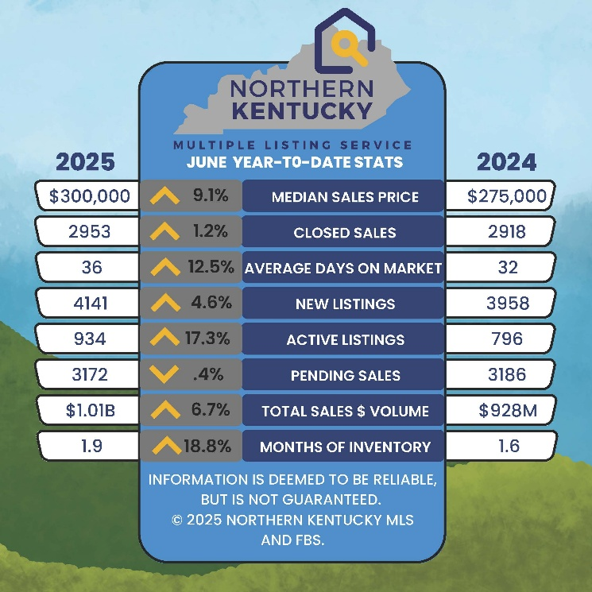

Market Trends (July 2025 v. 2024)
- Closed Sales were 2.6 lower than in July 2024- 557/572.
- Median Sales Price up by 3.2% to $292,000.
- Average Days on Market increased to 29 days or a 11.5% increase.
- Total Active Listings increased to 1109 or a 16% increase.
- Pending Sales were up from 2024 with 580 v. 525 or an 10.5% increase.
- Sales Volume dropped slightly by .8% or $185.9 million in the July 24/25 comparison.
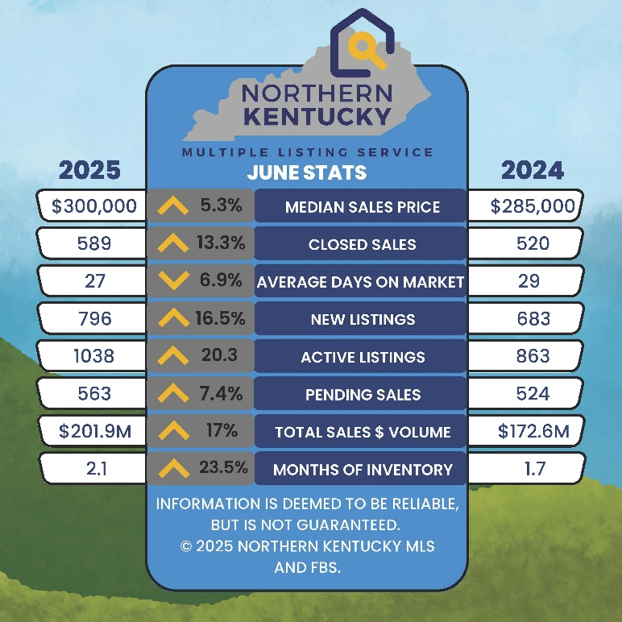
Commenting on these market trends, Jen Swendiman, President of the Northern Kentucky Association of REALTORS®, stated, Year to Date in July 2025 vs 2024, as shown in the graphics above, we saw positive improvements in the number of Active Listings giving Buyers more options to choose from. Pending sales continue to increase as well even though Days on Market also increased slightly. With mortgage rates at their lowest since October and the availability of more homes on the market, the approaching fall market could be an improvement for both Buyers and Sellers.
With almost 1930 MLS users, the Northern Kentucky MLS (NKMLS) is a leader in the real estate information and services business and operates with a professional staff from 7660 Turfway Road, Suite 100 in Florence, KY. Both NKAR and the NKMLS work to protect the public’s right to transfer real property and promote better public understanding of the profession and the real estate transaction process.

