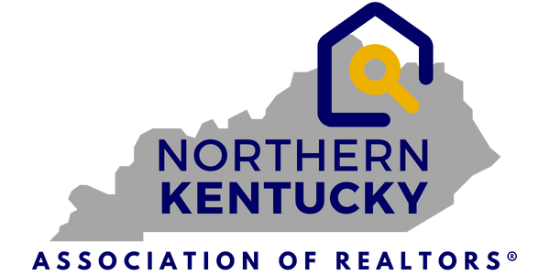
7660 Turfway Rd.
Suite 100
Florence, KY 41042
859-344-8400
FOR IMMEDIATE RELEASE
SEPTEMBER 23, 2025
PRESS RELEASE
Contact: Jen Swendiman, President
Northern Kentucky Association of REALTORS®
Telephone: 859-344-8400
E-mail: Jswendiman@handinhandrealtyky.com
Northern Kentucky Real Estate Market Update – September 23, 2025
Florence, KY – September 23, 2025 – The Northern Kentucky Association of REALTORS® and The
Northern Kentucky Multiple Listings Service, Inc. (MLS) reported today that in August, year-to-date, active listings in the 12 counties served by the local MLS is up 15.7%.
Shown in the graphic below, Year-To-Date, the August Median Sales Price role by 6.3%, bring the total sales volume up 7% to $1.29 billion. The number of closed sales only showed a .7% increase.
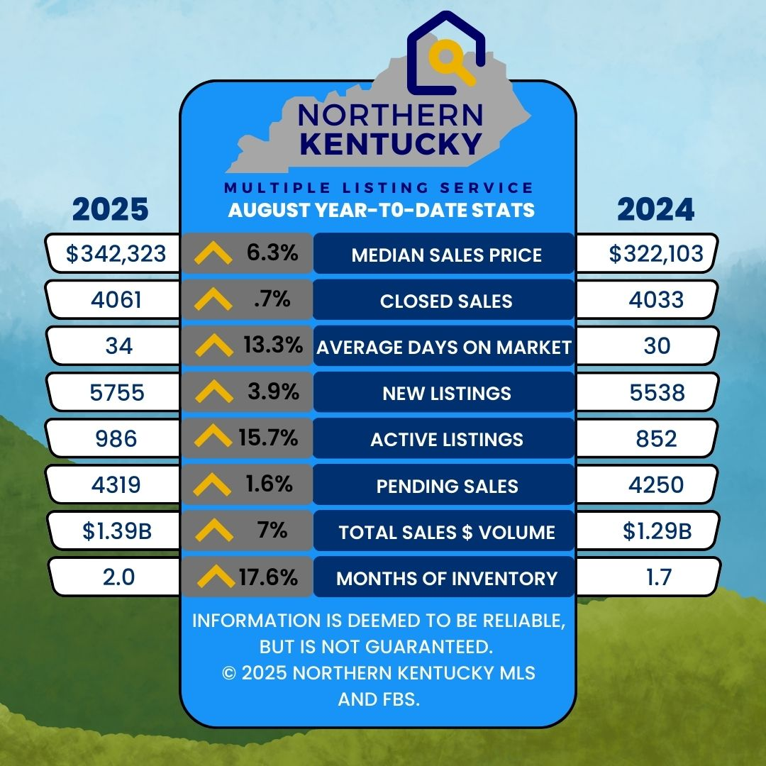

Market Trends (August 2025 v. 2024)
- Closed Sales were 1.7% lower than in August 2024- 534/543.
- Median Sales Price down by 1.6% to $300,000.
- Average Days on Market increased to 27 days or a 22.7% increase.
- Total Active Listings increased to 1117 - a 5.6% increase.
- Pending Sales were up from 2024 with 585 v. 539 or an 8.5% increase.
- Sales Volume dropped by 1.3% to $181 million in the August 24/25 comparison.
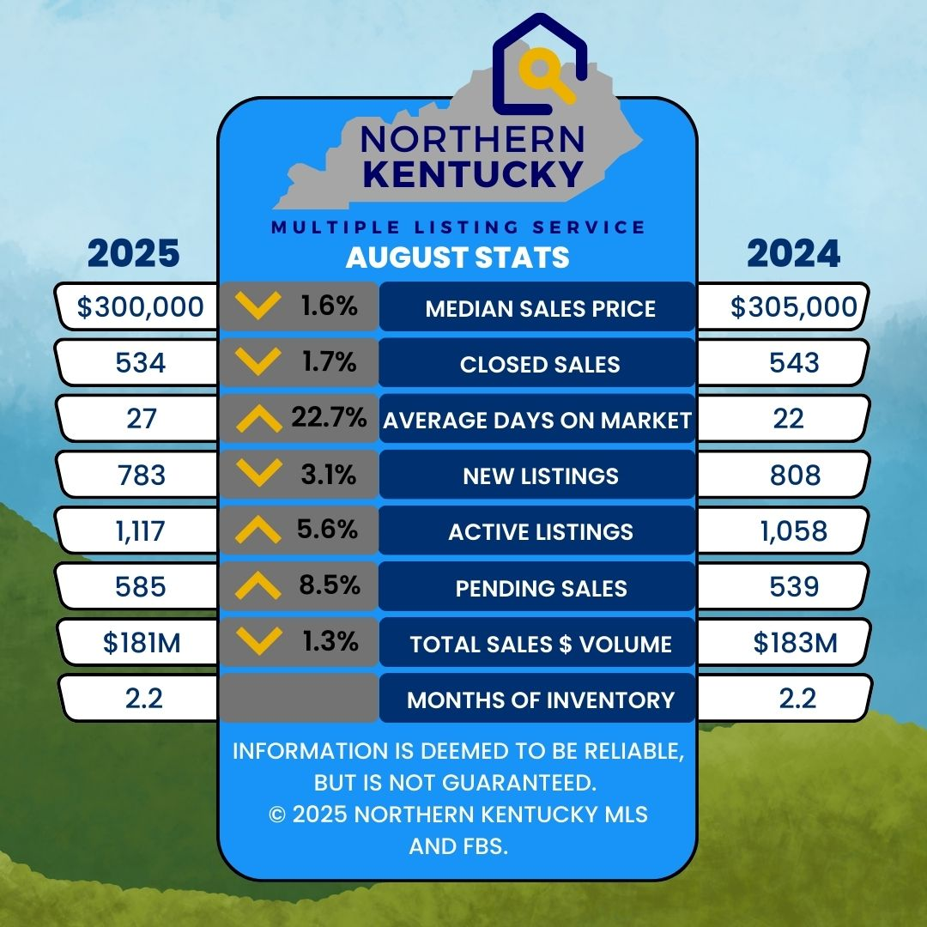
Commenting on these market trends, Jen Swendiman, President of the Northern Kentucky Association of REALTORS®, stated, “Year to Date in August 2025 vs 2024, as shown in the graphics above, the number of Active Listings was the most significant increase which gave us 2.0 months of inventory. For August 2025 vs 2024, the market slowed slightly with fewer new listings but an increase in pending sales. The Median Sales price dropped to $300,00 and Days on Market increased to 27 days giving Buyers a slight break in the demanding market conditions we’ve been experiencing.”
With just over 1900 MLS users, the Northern Kentucky MLS (NKMLS) is a leader in the real estate information and services business and operates with a professional staff from 7660 Turfway Road, Suite 100 in Florence, KY. Both NKAR and the NKMLS work to protect the public’s right to transfer real property and promote better public understanding of the profession and the real estate transaction process.

