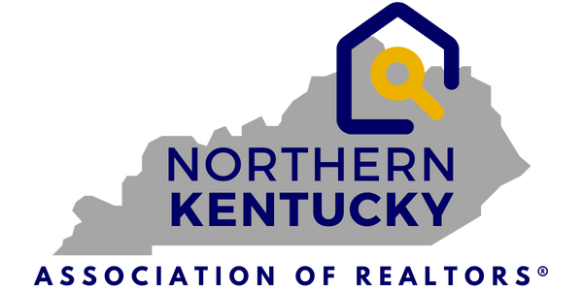
7660 Turfway Rd.
Suite 100
Florence, KY 41042
859-344-8400
FOR IMMEDIATE RELEASE
OCTOBER 23, 2025
PRESS RELEASE
Contact: Jen Swendiman, President
Northern Kentucky Association of REALTORS®
Telephone: 859-344-8400
E-mail: jen.swendiman@exprealty.com
Northern Kentucky Real Estate Market Update – October 23, 2025
Florence, KY – October 23, 2025 – The Northern Kentucky Association of REALTORS® and The
Northern Kentucky Multiple Listings Service, Inc. (MLS) reported today that in September, year-to-date, active listings in the 12 counties served by the local MLS is up once again, by double digits, to 14.9%.
Shown in the graphic below, Year-To-Date, the September Median Sales Price rose by 7.1%, bringing the total sales volume up 7.9% to $1.59 billion. The number of closed sales showed a slight positive gain of 1.2%.
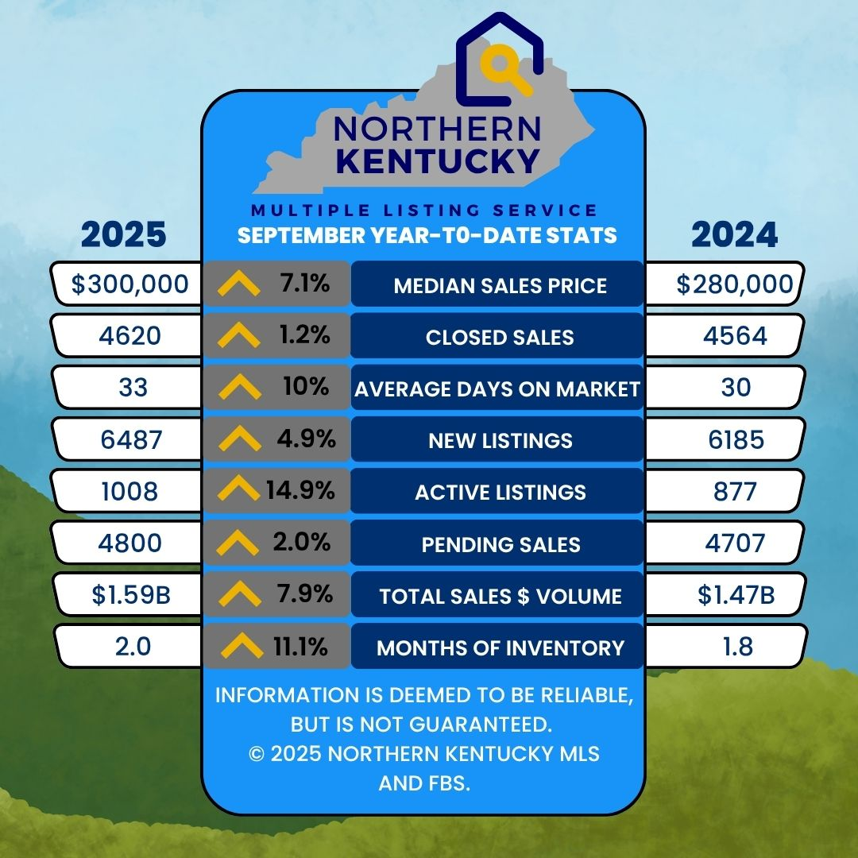

Market Trends (September 2025 v. 2024)
- Closed Sales were 2.8% better than in September 2024- 546/531.
- Median Sales Price up 5.6% to $306,000.
- Average Days on Market remained steady at 28 days.
- Total Active Listings increased to 1150 - an increase of 5.7%.
- Pending Sales were up from September 2024 with 483 v. 457 or an 5.7% increase.
- Sales Volume increased by 11.7% to $193 million in the September 24/25 comparison.
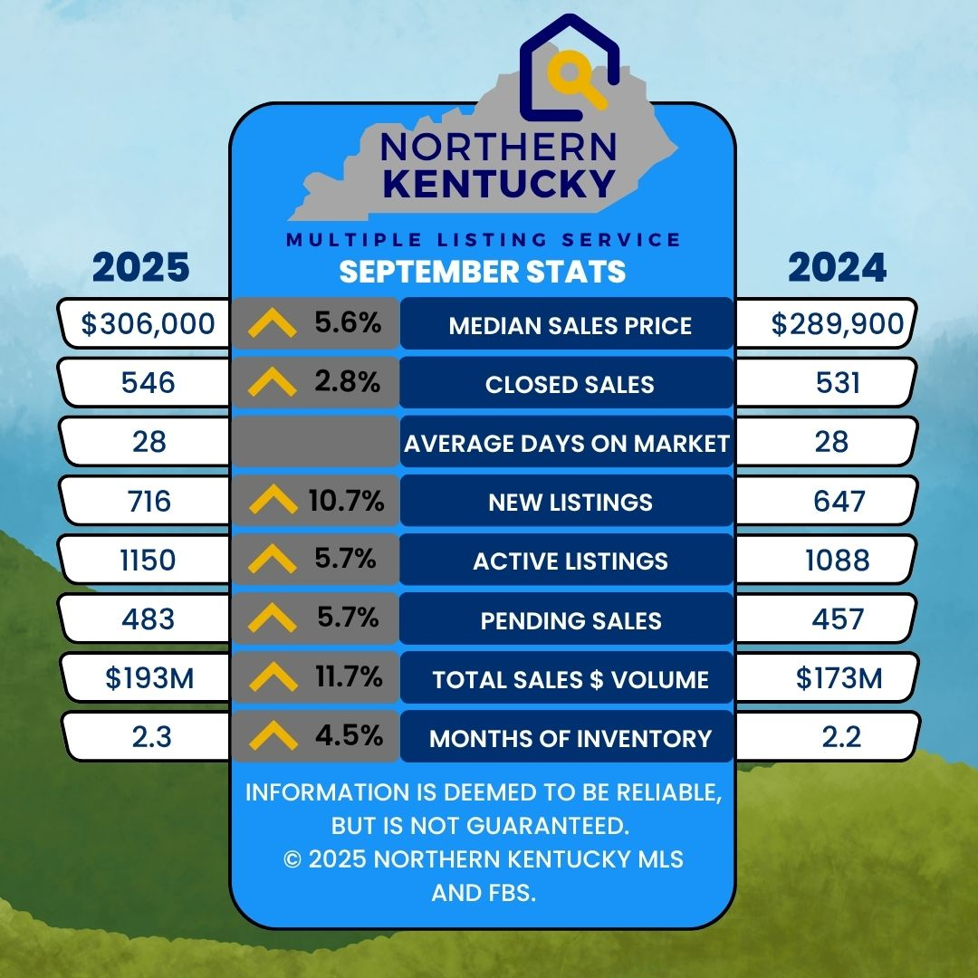
Commenting on these market trends, Jen Swendiman, President of the Northern Kentucky Association of REALTORS®, stated, “September showed all positive gains both Year to Date and in September 2025 vs 2024, as shown in the graphics above. The number of Active Listings was the most significant increase Year to Date, which remains at 2.0 months of inventory. For September 2025 vs 2024, the market gained slightly with increases in Active, Pending and Closed Sales. The increase in Active Listings and slight adjustment in interest rates has given Buyers more options to choose from, keeping Northern Kentucky a great place to call home.”
With just over 1900 MLS users, the Northern Kentucky MLS (NKMLS) is a leader in the real estate information and services business and operates with a professional staff from 7660 Turfway Road, Suite 100 in Florence, KY. Both NKAR and the NKMLS work to protect the public’s right to transfer real property and promote better public understanding of the profession and the real estate transaction process.

